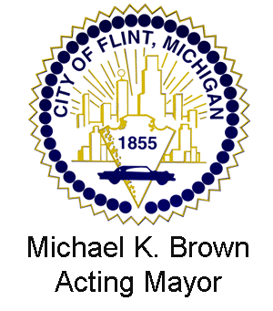
AGENDA

FLINT ZONING BOARD OF APPEALS

March 17, 2015

Dayne Walling Gerald Ambrose
Mayor Emergency Manager

Pursuant to Public Act 267 of 1976, "Open Meetings Act", all meetings of the Board are open to the public and the public is welcome to address the Board on any item under its jurisdiction or on its agenda.

6:00 P.M. COMMITTEE-OF-THE-WHOLE MEETING ROOM (3rd Floor of City Hall)

- ROLL CALL
- ADOPTION OF THE AGENDA
- APPROVAL OF MINUTES
- January 20, 2015

- REPORTS OF COMMITTEES
- CITY ATTORNEY REPORT
- COMMUNICATIONS
- PUBLIC HEARING
- PUBLIC HEARING
- ZBA 15-2200 Verizon Wireless requests a variance for required setbacks for a wireless communication tower/facility proposed to be located at 4090 N. Dort Hwy., parcel # 47-32-326-006.

- UNFINISHED BUSINESS

- NEW BUSINESS
- PUBLIC FORUM
- ADJOURNMENT

