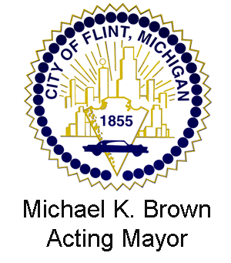
CITY OF FLINT
HISTORIC DISTRICT COMMISSION

DAYNE WALLING NATASHA L. HENDERSON
Mayor City Administrator

FLINT HISTORIC DISTRICT COMMISSION
2015-2016 MEMBERSHIP ROSTER

WARD 7 Dr. Mildred Smith Exp 7-30-06

WARD 8 Dale Suomela Exp 2-29-08

WARD 7 Heather Burnash Exp 2-22-13

WARD 8 Michael Hurley Exp 4-11-14

WARD 2 Maurice Davis Exp 3-31-17

WARD 2 Stephanie Wright Exp 3-31-17

Presiding Officers (term April 2015 - April 2016)

Dale Suomela, Chair
Heather Burnash, Vice-Chair

