ETHICS AND ACCOUNTABILITY BOARD

PUBLIC NOTICE
** MEETING CANCELLATION***
Ethics and Accountability Board Meeting
NOTICE IS HERBY GIVEN THAT THE CITY OF FLINT ETHICS AND ACCOUNTABILITY BOARD MEETING scheduled for February 29, 2024, at 5:30 p.m. has been CANCELLED.

The meeting will reconvene on Tuesday, March 12, 2024, at 5:30 p.m.

If there are any questions concerning this notice, please direct them to the Office of the Ombudsperson at (810) 237-2020.
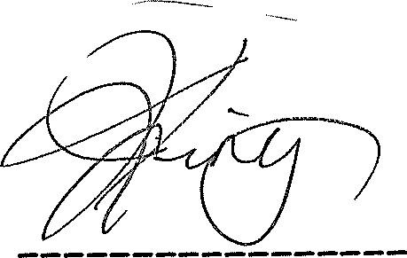
Joseph King, Chairman
Posted 2/21/2024
MUNICIPAL CENTER
1101 S. SAGINAW ST. FLINT, MICHIGAN 48502 (810) 766-7418 FAX (810) 766-7032 TDD (810) 766-7120

